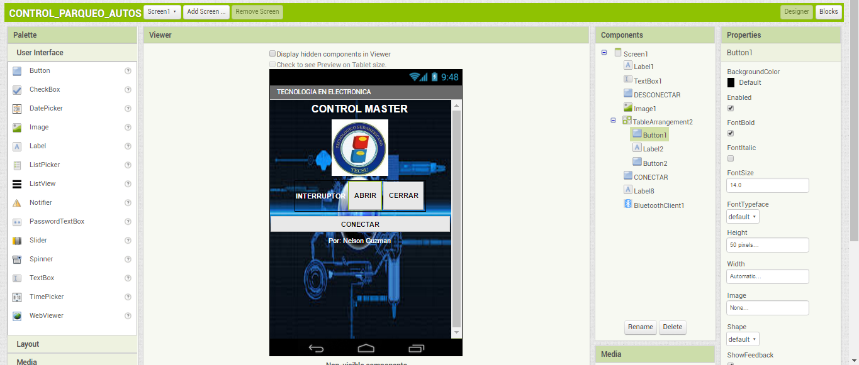

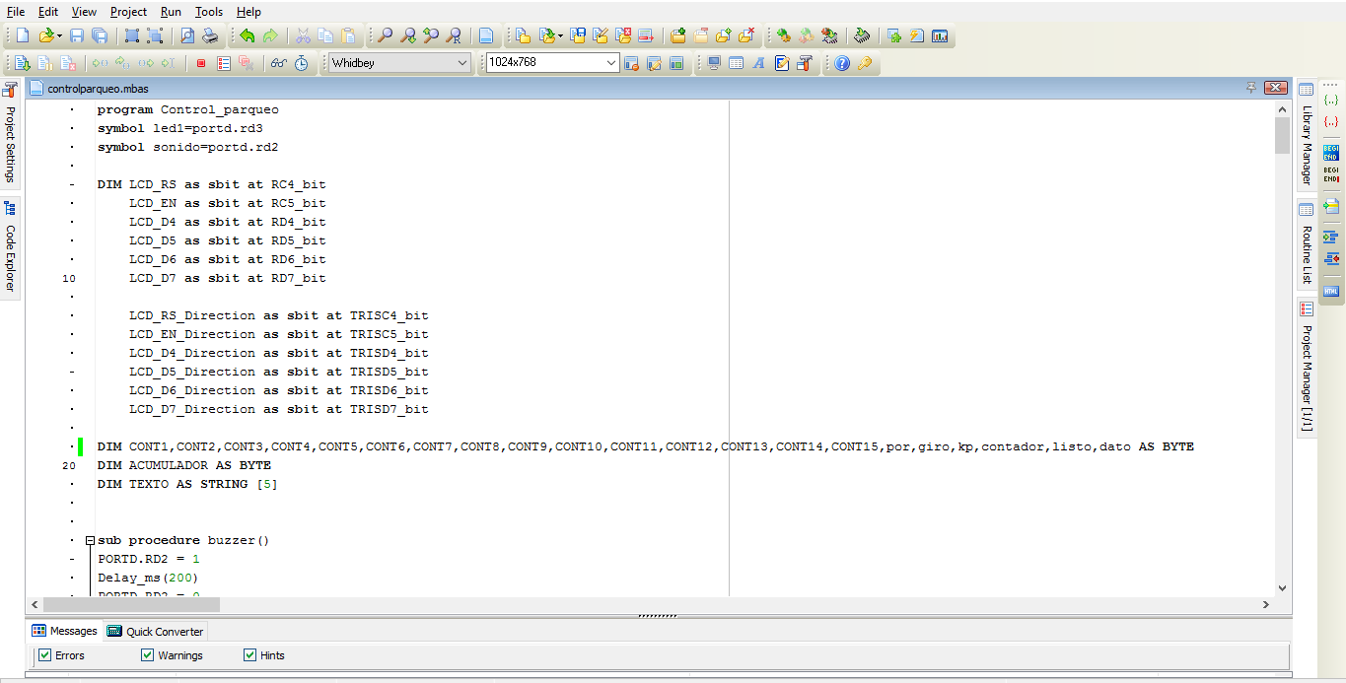

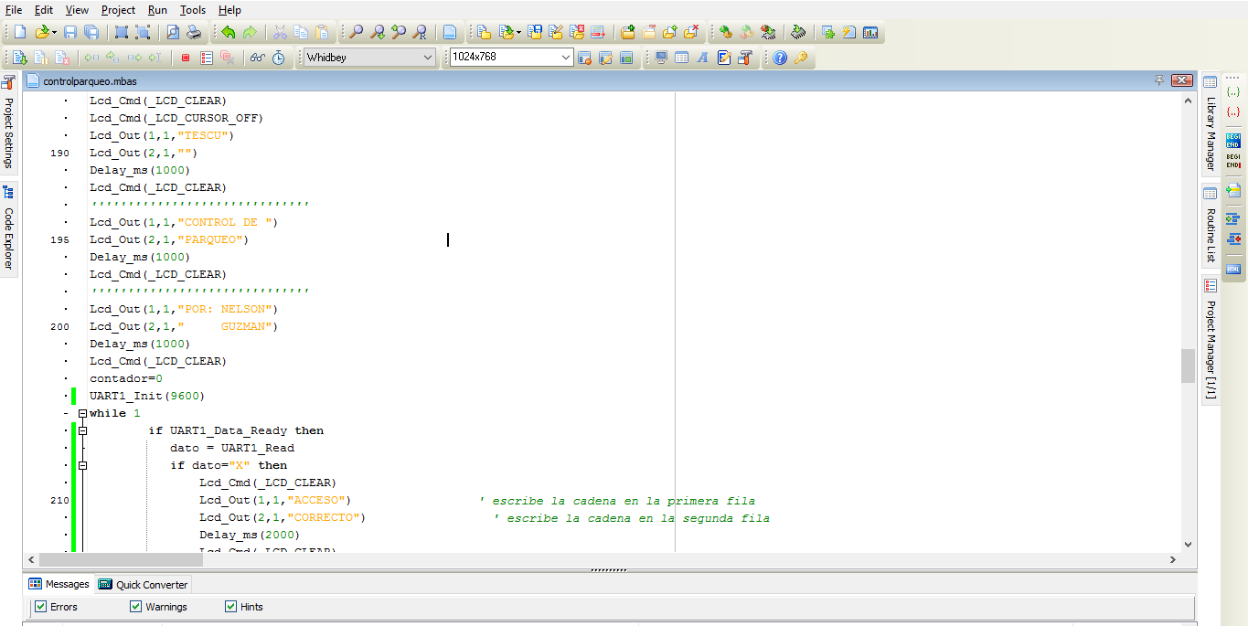

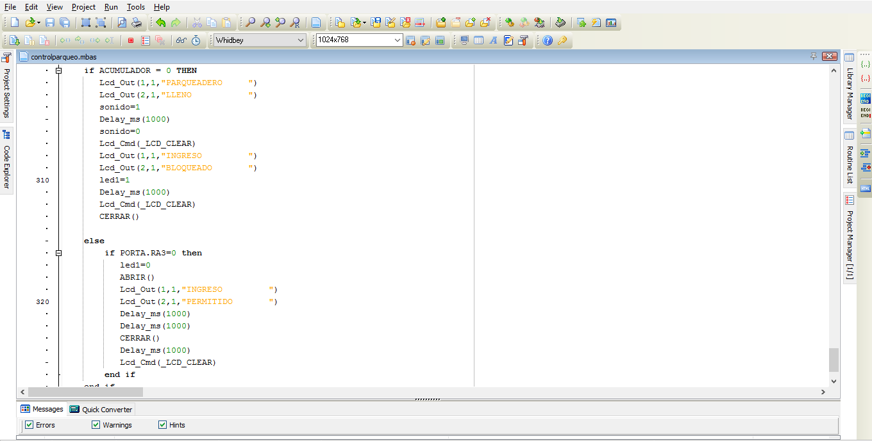

program Control_parqueo

symbol led1=portd.rd3

symbol sonido=portd.rd2

DIM LCD_RS as sbit at RC4_bit

LCD_EN as sbit at RC5_bit

LCD_D4 as sbit at RD4_bit

LCD_D5 as sbit at RD5_bit

LCD_D6 as sbit at RD6_bit

LCD_D7 as sbit at RD7_bit

LCD_RS_Direction as sbit at TRISC4_bit

LCD_EN_Direction as sbit at TRISC5_bit

LCD_D4_Direction as sbit at TRISD4_bit

LCD_D5_Direction as sbit at TRISD5_bit

LCD_D6_Direction as sbit at TRISD6_bit

LCD_D7_Direction as sbit at TRISD7_bit

DIM CONT1,CONT2,CONT3,CONT4,CONT5,CONT6,CONT7,CONT8,CONT9,CONT10,CONT11,CONT12,CONT13,CONT14,CONT15,por,giro,kp,contador,listo,dato,datorx,tecla AS BYTE

DIM ACUMULADOR AS BYTE

DIM TEXTO AS STRING [5]

DIM ESTACION1, ESTACION2,ESTACION3 AS BIT

sub procedure buzzer()

PORTD.RD2 = 1

Delay_ms(200)

PORTD.RD2 = 0

Delay_ms(200)

end sub

sub procedure abrir()

dim i as longword

i=0

while (i<10000)

inc(i)

if INTCON.TMR0IF=1 THEN

if por=1 then

giro=109

por=2

PORTD.RD1=0

GOTO final

end if

if por=2 then

giro=243

por=1

PORTD.RD1=1

GOTO final

end if

final:

TMR0 = giro

INTCON = 0x20

end if

wend

end sub

sub procedure cerrar()

dim i as longword

i=0

while (i<10000)

inc(i)

if INTCON.TMR0IF=1 THEN

if por=1 then

giro=114

por=2

PORTD.RD1=0

GOTO final

end if

if por=2 then

giro=238

por=1

PORTD.RD1=1

GOTO final

end if

final:

TMR0 = giro

INTCON = 0x20

end if

wend

End sub

sub procedure leer_teclado()

kp = 0

portb=%11101111 'EXPLORO FILA 1

if(portb.0=0)then 'EXPLORO COLUMNA1

while(portb.0=0) wend

kp=0x31 end if'1

if(portb.1=0)then 'EXPLORO COLUMNA2

while(portb.1=0) wend

kp=0x32 end if'2

if(portb.2=0)then 'EXPLORO COLUMNA3

while(portb.2=0) wend

kp=0x33 end if'3

if (portb.3=0)then 'EXPLORO COLUMNA4

while(portb.3=0) wend

kp=$41 end if'A

if(kp=0)then

portb=%11011111 'EXPLORO FILA 2

if(portb.0=0)then 'EXPLORO COLUMNA1

while(portb.0=0) wend

kp=0x34 end if'4

if(portb.1=0)then 'EXPLORO COLUMNA2

while(portb.1=0) wend

kp=0x35 end if'5

if(portb.2=0)then 'EXPLORO COLUMNA3

while(portb.2=0) wend

kp=0x36 end if'6

if (portb.3=0)then 'EXPLORO COLUMNA4

while(portb.3=0) wend

kp=$42 end if'B

else return

end if

if(kp=0) then

portb=%10111111 'EXPLORO FILA 3

if(portb.0=0)then 'EXPLORO COLUMNA1

while(portb.0=0) wend

kp=0x37 end if'7

if(portb.1=0)then 'EXPLORO COLUMNA2

while(portb.1=0) wend

kp=0x38 end if'8

if(portb.2=0)then 'EXPLORO COLUMNA3

while(portb.2=0) wend

kp=0x39 end if'9

if (portb.3=0)then 'EXPLORO COLUMNA4

while(portb.3=0) wend

kp=$43 end if'C

else return

end if

if(kp=0)then

portb=%01111111 'EXPLORO FILA 4

if(portb.0=0)then 'EXPLORO COLUMNA1

while(portb.0=0) wend

kp=$23 end if '*

if(portb.1=0)then 'EXPLORO COLUMNA2

while(portb.1=0) wend

kp=0x30 end if'0

if(portb.2=0)then 'EXPLORO COLUMNA3

while(portb.2=0) wend

kp=$24 end if'#

if (portb.3=0)then 'EXPLORO COLUMNA4

while(portb.3=0) wend

kp=$44 end if'D

else return

end if

end sub

main:

OSCCON = 0X65

OPTION_REG=0X06

'OPTION_REG=%00000111 ' teclado

WPUB = $0F

PORTA = %00000000

TRISA = %11111111

PORTB = %00000000

TRISB = %00001111

PORTC = %00000000

TRISC = %10000000

PORTD = %00000000

TRISD = %00000000

PORTE = %00000000

TRISE = %00000000

ANSEL = %00000000

ANSELH = %00000000

UART1_Init(9600)

Delay_ms(200)

'INTCON = 0XC0

'PIR1.RCIF=0

'PIE1.RCIE=1

'por=2

'TMR0=100

listo=0

dato=0

CONT1 =0

CONT2 =0

CONT3 =0

CONT4 =0

CONT5 =0

CONT6 =0

CONT7 =0

CONT8 =0

CONT9 =0

CONT10 =0

CONT11 =0

CONT12 =0

CONT13 =0

CONT14 =0

CONT15 =0

ESTACION1=0

ESTACION2=0

ESTACION3=0

Lcd_Init()

Lcd_Cmd(_LCD_CLEAR)

Lcd_Cmd(_LCD_CURSOR_OFF)

Lcd_Out(1,1,"TESCU")

Lcd_Out(2,1,"")

Delay_ms(1000)

Lcd_Cmd(_LCD_CLEAR)

''''''''''''''''''''''''''''''

Lcd_Out(1,1,"CONTROL DE ")

Lcd_Out(2,1,"PARQUEO")

Delay_ms(1000)

Lcd_Cmd(_LCD_CLEAR)

''''''''''''''''''''''''''''''

Lcd_Out(1,1,"POR: NELSON")

Lcd_Out(2,1," GUZMAN")

Delay_ms(1000)

Lcd_Cmd(_LCD_CLEAR)

contador=0

tecla=1

while 1

if UART1_Data_Ready then

datorx = UART1_Read

end if

if datorx="X" then

Lcd_Cmd(_LCD_CLEAR)

Lcd_Out(1,1,"ACCESO") ' escribe la cadena en la primera fila

Lcd_Out(2,1,"CORRECTO") ' escribe la cadena en la segunda fila

Delay_ms(2000)

Lcd_Cmd(_LCD_CLEAR)

datorx=0

end if

if datorx="Y" then

Lcd_Cmd(_LCD_CLEAR)

Lcd_Out(1,1,"ACCESO") ' escribe la cadena en la primera fila

Lcd_Out(2,1,"NEGADO") ' escribe la cadena en la segunda fila

Delay_ms(2000)

Lcd_Cmd(_LCD_CLEAR)

datorx=0

end if

leer_teclado()

if KP<>0 then

'UART1_Write(kp) ' ENVIA NUMERO

while(tecla=1)

leer_teclado()

if KP<>0 then

Delay_ms(200) ' TIEMPO DE ESPERA

contador = contador+1

buzzer

IF (kp = 0X31) and (contador=1) then

Lcd_Cmd(_LCD_CLEAR)

listo = listo + 1

Lcd_Out(2,1,"*")

end if

IF (kp = 0X32) and (contador=2) then

Lcd_Cmd(_LCD_CLEAR)

listo = listo + 1

Lcd_Out(2,1,"**")

end if

IF (kp = 0X33) and (contador=3) then

Lcd_Cmd(_LCD_CLEAR)

listo = listo + 1

Lcd_Out(2,1,"***")

end if

IF (kp = 0X34) and (contador=4) then

Lcd_Cmd(_LCD_CLEAR)

listo = listo + 1

Lcd_Out(2,1,"****")

end if

Delay_ms(300)

if CONTADOR=4 then

buzzer

buzzer

buzzer

Lcd_Cmd(_LCD_CLEAR)

' escribe la cadena en la segunda fila

if listo=4 then

listo=0

contador=0

Lcd_Out(1,1,"ACCESO") ' escribe la cadena en la primera fila

Lcd_Out(2,1,"CORRECTO") ' escribe la cadena en la segunda fila

Delay_ms(2000)

Lcd_Cmd(_LCD_CLEAR)

tecla=0

else

contador=0

listo=0

Lcd_Out(1,1,"ACCESO") ' escribe la cadena en la primera fila

Lcd_Out(2,1,"INCORRECTO") ' escribe la cadena en la segunda fila

Delay_ms(2000)

Lcd_Cmd(_LCD_CLEAR)

Lcd_Out(1,1,"INGRESE CLAVE") ' escribe la cadena en la primera fila

Lcd_Out(2,1,"")

Delay_ms(2000)

Lcd_Cmd(_LCD_CLEAR)

tecla=0

end if

end if

end if

wend

end if

ACUMULADOR=0

Lcd_Out(1,1,"LIBRES: ")

Lcd_Out(2,1,"OCUPADOS: ")

Lcd_Out(3,1,"ESTACION:")

if ESTACION1=1 THEN

Lcd_Out(4,3,"A")

else

Lcd_Out(4,3,"_")

end if

if ESTACION2=1 THEN

Lcd_Out(4,7,"B")

else

Lcd_Out(4,7,"_")

end if

if ESTACION3=1 THEN

Lcd_Out(4,11,"C")

else

Lcd_Out(4,11,"_")

end if

if PORTA.RA0 = 0 then CONT1 = 0 ESTACION1=0 ELSE CONT1 = 1 ESTACION1=1 end if

if PORTA.RA1 = 0 then CONT2 = 0 ESTACION2=0 ELSE CONT2 = 1 ESTACION2=1 end if

if PORTA.RA2 = 0 then CONT3 = 0 ESTACION3=0 ELSE CONT3 = 1 ESTACION3=1 end if

'if PORTA.RA3 = 0 then CONT4 = 0 ELSE CONT4 = 1 end if

' if PORTA.RA4 = 0 then CONT5 = 0 ELSE CONT5 = 1 end if

' if PORTA.RA5 = 0 then CONT6 = 0 ELSE CONT6 = 1 end if

' if PORTA.RA6 = 0 then CONT7 = 0 ELSE CONT7 = 1 end if

' if PORTA.RA7 = 0 then CONT8 = 0 ELSE CONT8 = 1 end if

' if PORTB.RB0 = 0 then CONT9 = 0 ELSE CONT9 = 1 end if

' if PORTB.RB1 = 0 then CONT10 = 0 ELSE CONT10 = 1 end if

' if PORTB.RB2 = 0 then CONT11 = 0 ELSE CONT11 = 1 end if

' if PORTB.RB3 = 0 then CONT12 = 0 ELSE CONT12 = 1 end if

' if PORTB.RB4 = 0 then CONT13 = 0 ELSE CONT13 = 1 end if

' if PORTB.RB5 = 0 then CONT14 = 0 ELSE CONT14 = 1 end if

' if PORTB.RB6 = 0 then CONT15 = 0 ELSE CONT15 = 1 end if

ACUMULADOR = CONT1 +CONT2 +CONT3 +CONT4 +CONT5 +CONT6 +CONT7 +CONT8 +CONT9 +CONT10 +CONT11 +CONT12 +CONT13 +CONT14 +CONT15

ByteToStr(3-ACUMULADOR, TEXTO)

Lcd_Out(1,10,TEXTO)

ByteToStr(ACUMULADOR, TEXTO)

Lcd_Out(2,10,TEXTO)

Delay_ms(100)

if UART1_Data_Ready=1 then

dato = UART1_Read

end if

if (ACUMULADOR = 3)and(PORTA.RA3=1) THEN

Lcd_Out(1,1,"PARQUEADERO ")

Lcd_Out(2,1,"LLENO ")

sonido=1

Delay_ms(1000)

sonido=0

Lcd_Cmd(_LCD_CLEAR)

Lcd_Out(1,1,"INGRESO ")

Lcd_Out(2,1,"BLOQUEADO ")

led1=1

Delay_ms(1000)

Lcd_Cmd(_LCD_CLEAR)

CERRAR()

else

if PORTA.RA3=1 then

led1=0

'ABRIR()

Lcd_Out(1,1,"INGRESO ")

Lcd_Out(2,1,"PERMITIDO ")

'Delay_ms(1000)

Delay_ms(1000)

'CERRAR()

'Delay_ms(1000)

Lcd_Cmd(_LCD_CLEAR)

end if

end if

wend

end.